Rapport Practicum

Paul de Geus s1397451

# Introduction

Barley (*Hordeum vulgare*) is a member of the grass family. A Cereal grain growing mostly within temperate climates on Earth. It was one of the grains first cultivated around 10k years ago. Especially in Eurasia. It is utilized as animal fodder, is a component of several health foods and is fermented to create alcoholic beverages.



*Figure 1: current distribution of Hordeum Vulgare*

In 2014 Barley was ranked 4th among grains in produced quantity. In temperate regions Barley is harvested during the summer. In tropical regions harvest takes place during the colder period of the year. This report will investigate the geographic change in habitat distribution of barley in the Netherlands by comparing present and future climatic factors. These factors will result in species distribution models (SDMs).

# Methodology

In order to produce the SDMs two software programs were used: R-studio and MaxEnt. Distribution data was downloaded from gbif.org. the data set contained roughly 350 observations including coordinates. The bioclim variables were downloaded from worldclim.org. For the present data, the 5 min bioclim variables were selected. For the future bioclim variables the 5 min rcp60 files were selected. The R script used to produce the data input for MaxEnt was provided by Leon Marshall. This script first selects the range within which the geographic coordinates lie. Then it selects the climate variables which will be used to produce the SDMs. The scripts produced a table which indicates correlation between the climate-variables. The minimum correlation limit was set to .7

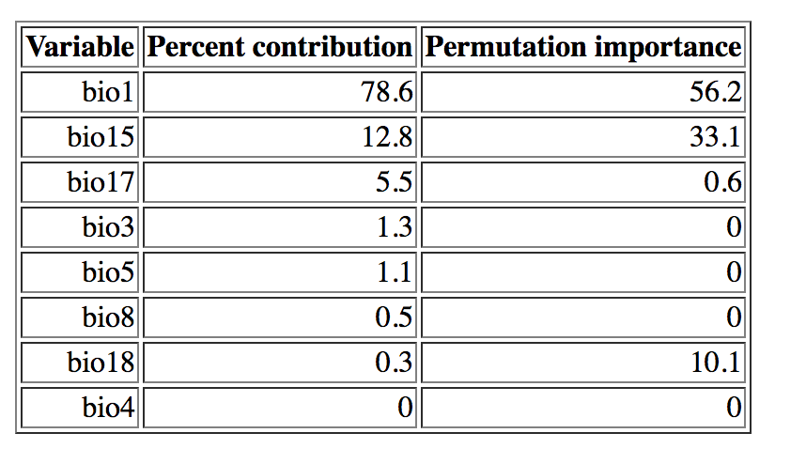

*Table 1: climate variables indicating contribution and importance.*

The climate variables were selected with respect to the importance for *H. vulgare.* Because the area of research was the Netherlands and because it is a crop harvested in the summer certain bioclim variables were judges more important than others. For instance, Temperature of warmest month was deemed more important than annual mean temperature of driest quarter. Because, the quantity of monthly precipitation does not vary much throughout the year in the Netherlands[1]. Bioclim variables were taken out until all correlation was removed from the data set. The remaining variables are shown in Table 1.

# Model Output

As can be seen in Table 1. The variable contributing most to the distribution is Annual Mean Temperature followed by Precipitation Seasonality. Figure 2 and 3 show that the predicted distribution of barley will not change dramatically between now and 2050.

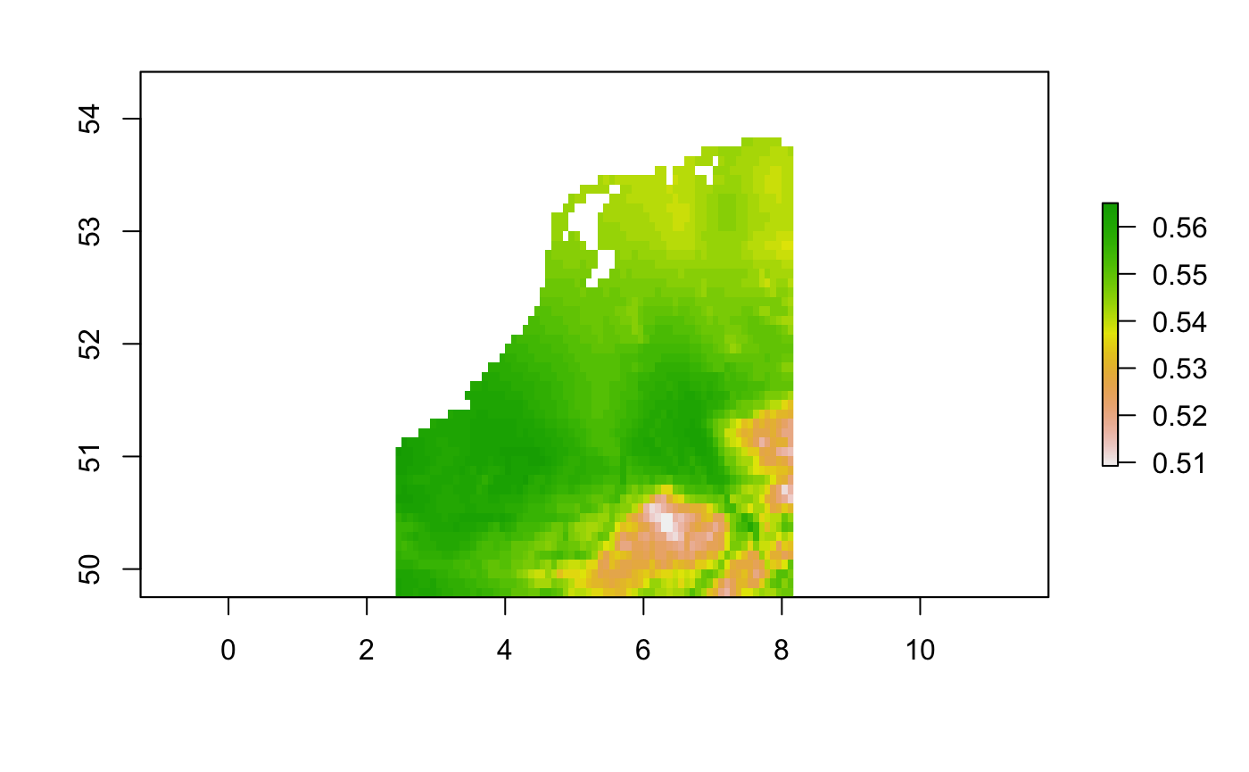

*Figure 2: Present day potential habitat distribution based on Bioclim variables.*

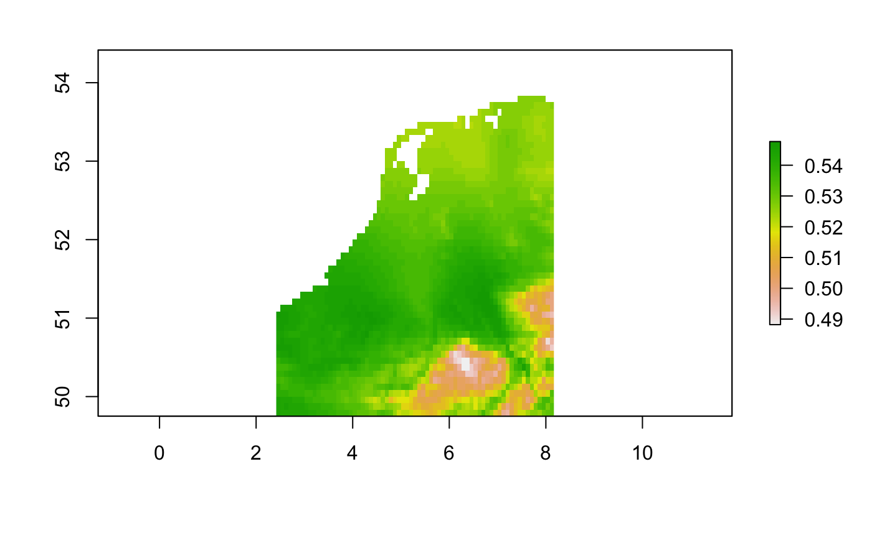

*Figure 3: Potential future (2050) habitat distribution based on Bioclim variables.*



*Figure 4:Graph depicting the AUV value of the model.*

The AUC value of .660 is not indicative of a good fitting model.

# Response to Future Scenario

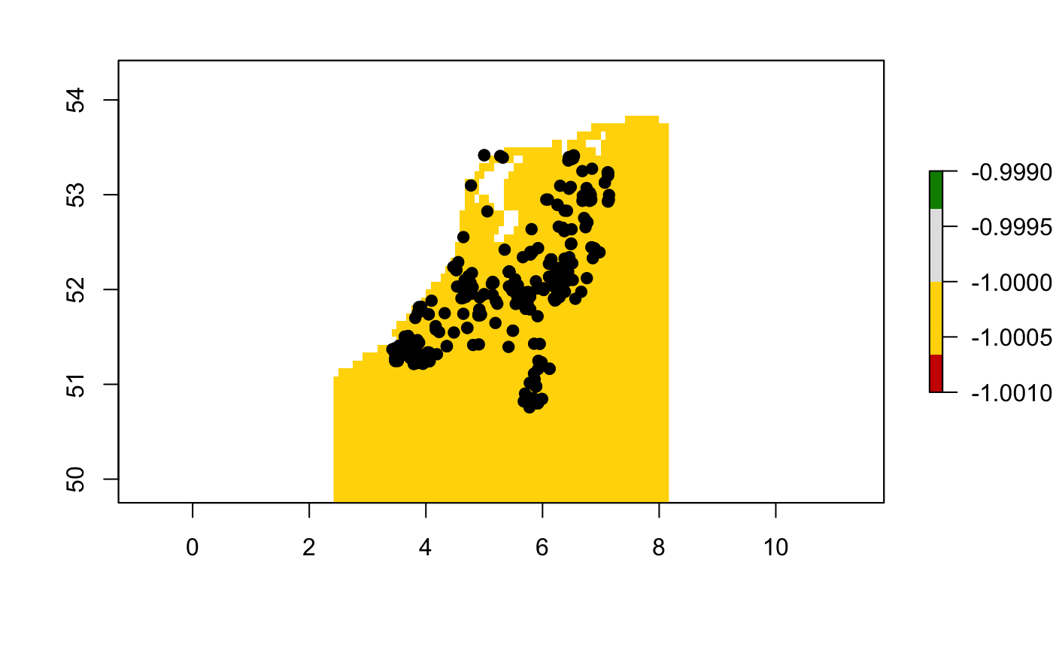

*Figure 5: Difference between present and future distribution change in the Netherlands.*

As seen in Figure 5 the distribution of Barley in the Netherlands will not change much between the present and 2050.

# Biological Interpretation

The SDMs predict that impending climate change is not going to impact the distribution of *H. vulgare* significantly. This is good news because, as stated in the introduction, this crop is the 4th largest produced grain crop. Meaning that, at least for barley, production can be maintained. Disregarding advances in yield due to improvement of agriculture technology. This model did predict that annual mean temperature is the highest contributing factor to barley distribution. Therefore, regions that will experience greater shifts in this variable will have greater problems when it comes to barley agriculture. This has the potential to be problematic. The second variable which will affect *H. vulgare* distribution is seasonal precipitation. This means that regions which will be subject to greater fluctuations in drought and perspiration will have greater difficulty with barley harvest. Lastly, SDMs should be produced for other climate types to say anything conclusive regarding its resilience and resistance to future climate change. The Netherlands only represents a coastal temperate climate.

1. http://www.weer.nl/verwachting/klimaat/nederland/nederland/1813809/